Southwest University
School of Computer & Information Science

Experiment Report

Course： C Programming
Topic ： string and pointer
Grade&class：Grade 2021 Class Computer Science 3
Student Name： 蔡前哲
Submission Date： 2022.6.5

1、Description of the problem （main task and the problem you resolved）
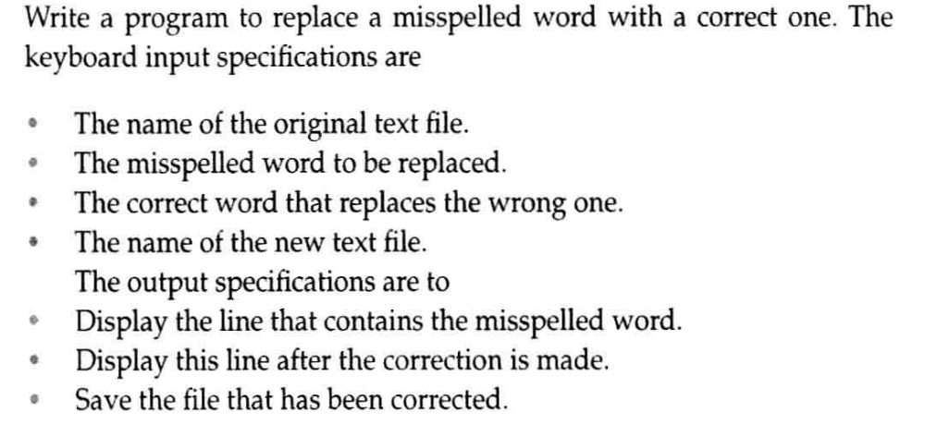

- Basic Conceptions and Principles
1. fgets().
The C library function char *fgets(char *str, int n, FILE *stream) reads a line from the specified stream and stores it in the string pointed to by str. It stops when (n-1) characters are read, or when a newline is read, or when the end of the file is reached.
2. String handling
A string is an array of characters, each bit can be processed individually. A string must have \0 as a terminator and cannot be missing.
3. Global variables
Global variables are available to all functions throughout the program. Function does not need to pass parameters

- Design Scheme（your plan, includes the structure of your program and the necessary description）

The function list:
void input(); //读入程序需要的数据
void outmis(int line); //输出错误行
void outcrt(int a, int b); //输出改正行
void replace(); //替换错误词
void outfile(); //将正确内容输出到文件
int main(); //主函数
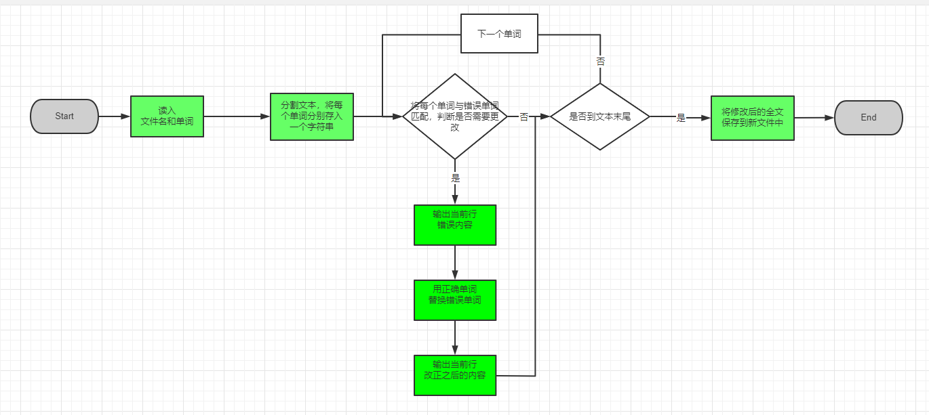
The structure chart of program is:

The data flow diagram for the general program is：
The file name where the text data is entered by the user, the program will automatically read all the contents of this file

4、Resource Code（detailed comments are required）
//Ex2main.c

#define _CRT_SECURE_NO_WARNINGS

#include<stdio.h>
#include<string.h>
#include<stdlib.h>
#include"Ex2InOut.h"
#include"Ex2Replace.h"

char fn[100], misword[100], crtword[100], newfn[100]; //输入文件名 错误单词 正确单词 输出文件名
char text[200][50]; //文章内容
int pun[200] = {0}; //对应单词是否最后一位含标点 0否1是
int num = 0; //文章单词个数
int nummis = 0; //错误行数量

int main()
{
input();
replace();
outfile();

printf("\n");
system("pause");

return 0;
}

//Ex2global.h

#ifndef _Ex2GLOBAL_H_
#define _Ex2GLOBAL_H_

extern char fn[100]; //输入文件名
extern char misword[100]; //错误单词
extern char crtword[100]; //正确单词
extern char newfn[100]; //输出文件名
extern char text[200][50]; //文章内容
extern int pun[200]; //对应单词是否最后一位含标点 0否1是
extern int num; //文章单词个数
extern int nummis; //错误行数量

#endif // !_Ex2GLOBAL_H_

//Ex2InOut.h

#ifndef _Ex2INOUT_H_
#define _Ex2INOUT_H_

void input(); //读入数据同时分割存入单词
void outmis(int line); //输出错误行
void outcrt(int a, int b); //输出改正行
void outfile(); //输出到文件

#endif // !_Ex2INOUT_H_

//Ex2InOut.c

#define _CRT_SECURE_NO_WARNINGS

#include<stdio.h>
#include<string.h>
#include<ctype.h>
#include"Ex2Global.h"

void input()
{
printf("Please enter the text file name...");
scanf("%s", fn);
printf("Please enter the misspelled word:");
scanf("%s", misword);
printf("Please enter the corret word:");
scanf("%s", crtword);
printf("Please enter the new file name:");
scanf("%s", newfn);
printf("\n");

FILE *fp;
fp = fopen(fn, "r");

char t[300];
while(fgets(t, 100, fp)) //按行读入同时处理 进行单词分割
{
int tlen = strlen(t);
int last = 0; //记录上一个空格位置

for(int i = 0; i < tlen; i++) //访问当前行所有字符
{
if(isalpha(t[i])) continue; //寻找单词分割标志 不是字母全部按分割符处理

if (i - last > 1)
{
int len = 0;
for (int j = last + 1; j < i; j++) //储存单词
{
text[num][len++] = t[j];
}
text[num][len] = '\0';
}

text[++num][0] = t[i]; //储存分割符
text[num][1] = '\0';

num++;

last = i;
if(t[i] == '\n') //处理换行符 需要重置last位置
last = 0;
}
}

fclose(fp);

}

void outmis(int start) //输出错误行 st记录text数组\n的下一个位置
{
nummis++;
printf("NO.%d\n", nummis);

printf("--The line that contains the misspelled word:\n");
int pos = start;
while (text[pos][0] != '\n' && pos < num)
{
printf("%s", text[pos]);
pos++;
}
printf("\n");
}

void outcrt(int a, int b) //输出改正行
{
printf("--The line after the correction is made:\n");
for(int j = a; j < b; j++)
printf("%s", text[j]);
printf("\n\n");
}

void outfile() //输出到文件
{
FILE *fp;
fp = fopen(newfn, "w");

for(int i = 0; i < num; i++)
{
fprintf(fp, "%s", text[i]);
}
fclose(fp);

printf("The correct text has been saved to %s", newfn);
}

//Ex2Replace.h

#ifndef _Ex2REPLACE_H_
#define _Ex2REPLACE_H_

void replace(); //替换错误单词

#endif // !_Ex2REPLACE_H_

//Ex2Replace.c

#define _CRT_SECURE_NO_WARNINGS

#include<string.h>
#include<stdio.h>
#include"Ex2InOut.h"
#include"Ex2Global.h"

void replace()
{
int st = 0, f = 0; //记录错误单词行开头位置 当前错误行是否已经输出
for(int i = 0; i < num; i++)
{
if(text[i][0] == '\n')
{
if(f) { outcrt(st, i); f = 0; } //前面输出过错误行 再次输出正确的 输出st到i之间的内容
st = i+1;
}

if(!strcmp(text[i], misword)) //是错误的词 进行替换并输出
{
if(!f) { f = 1; outmis(st); } //输出错误行

strcpy(text[i], crtword);
}
}

if(f) { outcrt(st, num); f = 0; } //到结尾没遇到换行符 判断是否需要输出
}
- Instructions(give the steps and necessary screenshot to show how to run your program):
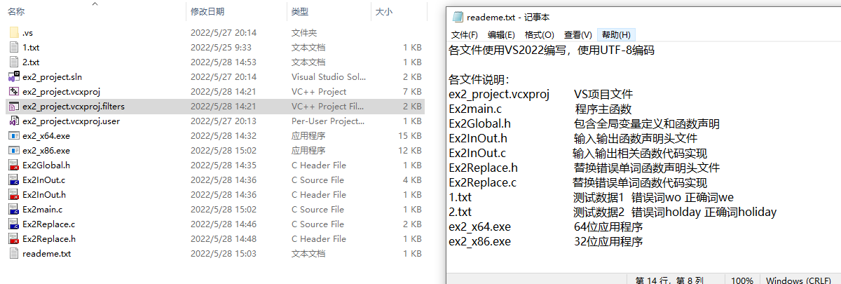
This experiment is written in multiple files. All relevant documents are shown above.
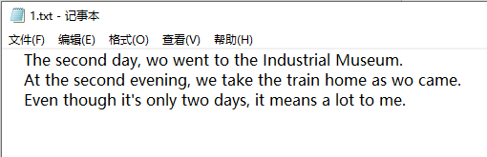
Suppose we need to modify the above file, “we” are wrongly written as “wo”. We need to correct the wrong words.

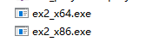
Select the corresponding exe file to open according to the number of bits of your computer (32 or 64).
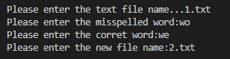
After opening the program, enter the corresponding content according to the program requirements. The “new file name” is the name of the file to be saved as a file after modification.
Note: The "2.txt" output here is not the data file in the folder in the picture above. I only have two files "1.txt" and "ex2_x64.exe" in the test folder. Please do not output the file with the same name as any file in the folder when you use the program！
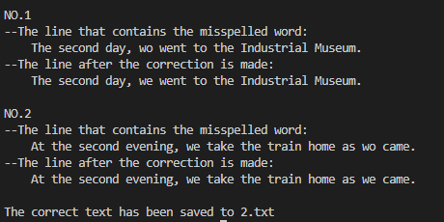
Then the program will automatically modify the wrong place and display it on the screen. After all modifications are completed, the correct content will be saved to a new file. The file name is the one you entered earlier. (I typed "2.txt" earlier)
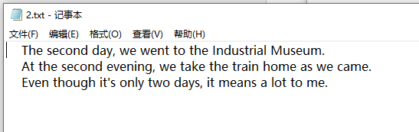
Open the new file and see that the correct content has been saved into it.
At this point the program has all been executed.

Screenshots of other test data results are as follows.

“1.c”
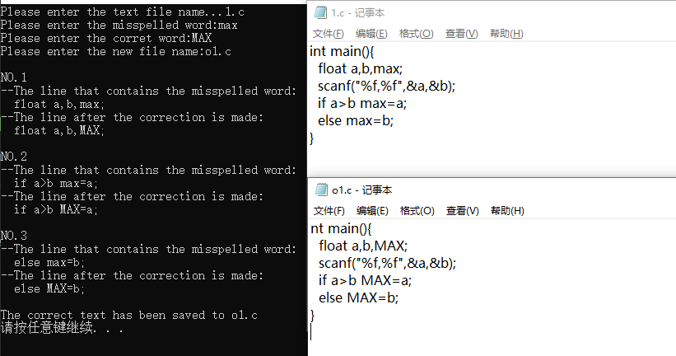

“2.txt”
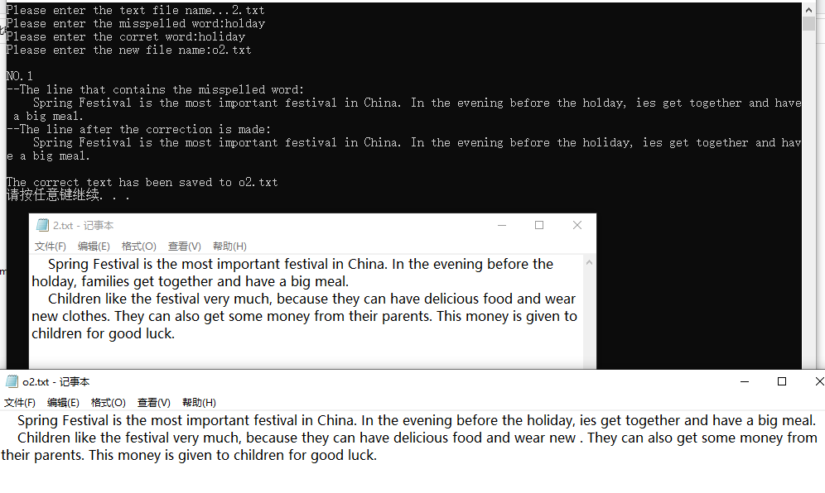
- Summary
1.My understanding of string functions is much deeper. The functions are summarized as follows.
strcpy(str1,str2): copy the string in str2 into str1
strncpy(str1,str2,n): Copy the first n characters in str2 to the first n characters in str1
Note:
1) This function will not clear all strings in str1, only the first n characters will be changed.
2) n cannot be greater than the length of str1 and str2.
3) Use strncpy_s to clear all strings in str1.
strcat(str1,str2): Add the string str2 to the end of the string str1, that is, splicing two strings.
Note: The length after splicing cannot exceed the length of the string array str1
strlen(str1): Calculate the length of the string str1.
Note: The length of the string does not include the character '\0'.
strcmp(str1,str2): Compare two strings, if the two strings are equal, return 0; if str1 is greater than str2 (for the understanding of greater than, it means to start the comparison from the first character of the two strings, if the two characters are the same, continue Compare, if it is found that the two characters are not equal, and the ASCII code of the character in str1 is greater than that in str2, it means that str1 is greater than str2), return a positive number (this positive number is not necessarily 1); if str1 is less than str2, return A negative number (not necessarily -1); if the length of the string str1 is greater than str2, and the character of str2 is the same as the character before str1, it is also processed relative to str1 greater than str2.
2. Large amounts of data are required to test programs and various edge cases are considered.
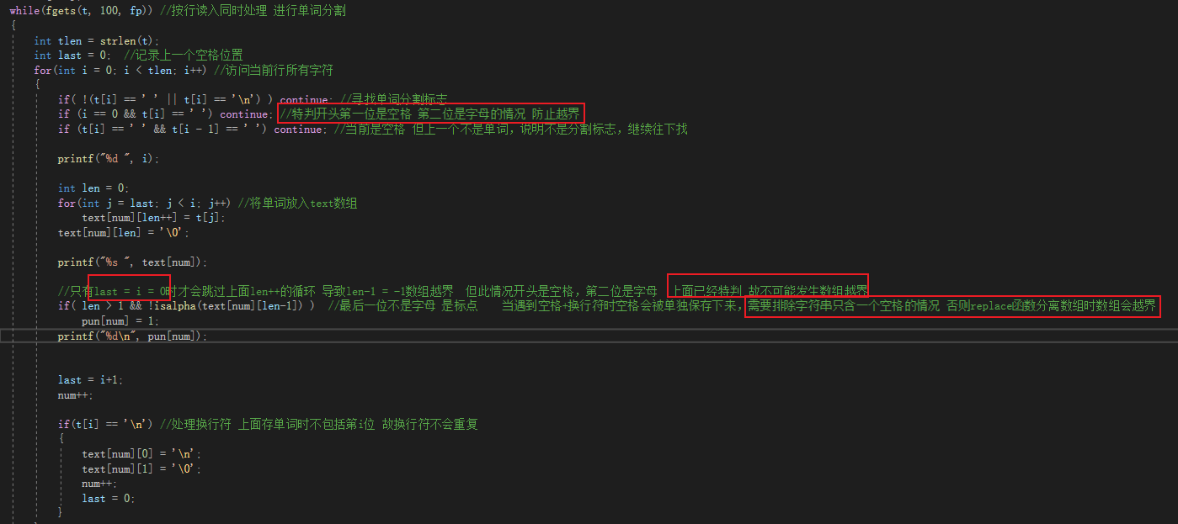
The picture above is part of the code of the input() function in "InOut.c".The content of the special sentence is marked in red. (The screenshot is the original idea, the submitted code has been improved and not the same as in the screenshot.)
After I wrote it, because the data is very standardized, I did not find any bugs. But after I modified the test data and added a lot of extreme boundary conditions, I found that sometimes the array of the program would go out of bounds. After many tests, I found that it is the problem of input() function and replace() function. In the end, I converted the program implementation idea and modified it into the content as shown above.

7.Reference
No reference.
Score：

Teacher（signature）：

Date:

Assessment Index |  | level
 |  | A | B | C | D | E
Program Correctness
Program Style& Interface
Report Standardization
Grade

